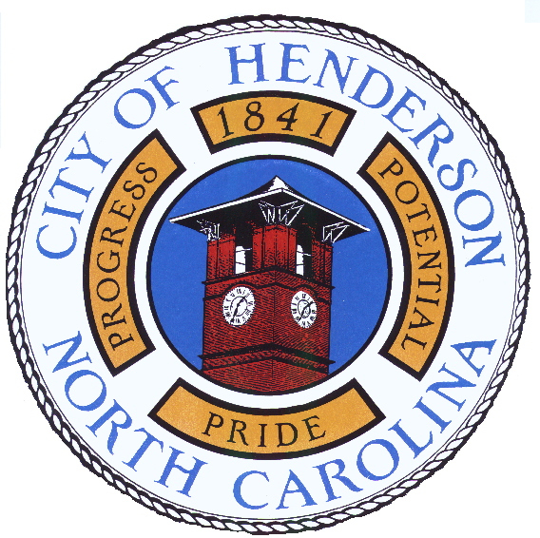

AGENDA
Henderson City Council Work Session
Monday, 22 August 2011 Immediately Following Regular Session
R. G. (Chick) Young, Jr. Council Chambers, Municipal Building
134 Rose Avenue
Henderson, North Carolina

Mayor and City Council Members
Mayor James D. O’Geary, Presiding

Councilmember James C. Kearney, Sr.
Councilmember Sara M. Coffey
Councilmember Michael C. Inscoe
Councilmember D. Michael Rainey

Councilmember Brenda G. Peace—Jenkins
Councilmember Garry D. Daeke
Councilmember Lonnie Davis, Jr.
Councilmember George M. Daye

City Officials

A. Ray Griffin, Jr., City Manager
John H. Zollicoffer, Jr., City Attorney
Esther J. McCrackin, City Clerk

- CALL TO ORDER

- ROLL CALL

- ADJUSTMENTS TO AND/OR APPROVAL OF THE AGENDA

- REGULAR WORK SESSION

a) Consideration of Ordinance 11—03, Authorizing FY 12 Budget Amendment #10, to Close Out the C ity Hall Renovation Project Budget. (CAF 11—09) [See Notebook Tab # 11]

● Ordinance 11—03

b) Consideration of Ordinance 11—23, Creating an Availability Charge for any Habitable Structure in the City for Failure to Connect to Available Water and Sewer. (CAF 11—A—17) [See Notebook Tab # 12]

● Ordinance 11—23
c) Consideration of CM 11—15, Industry Drive Water Main Extension Update. [See Notebook Tab # 13]

● CM 11—15

VI. ADJOURNMENT

